Reflog

What is Reflog?
# Source: AI Source: Provided by: [Data Path: Persons Table -> ID Column: 1, Name_En Column: Motasem Essam] -> From: [ChatGPT] on [2/15/2026]
In Git, a reflog (short for reference log) is like a safety net that records all movements of your HEAD and branches. It lets you see and recover commits even if they are “lost” or no longer reachable through normal branch history.

What reflog Does
# Source: AI Source: Provided by: [Data Path: Persons Table -> ID Column: 1, Name_En Column: Motasem Essam] -> From: [ChatGPT] on [2/15/2026]
- Tracks every change to HEAD, including:
  - Commits
  - Resets
  - Checkouts
  - Rebases
  - Merges
- Records where your branches and HEAD pointed at any point in time, with timestamps.
- Allows you to recover commits that might seem “deleted” after a reset, rebase, or force push.

How to View Reflog
# Source: AI Source: Provided by: [Data Path: Persons Table -> ID Column: 1, Name_En Column: Motasem Essam] -> From: [ChatGPT] on [2/15/2026]
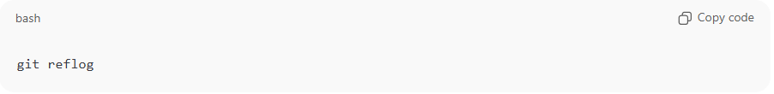
git reflog
This shows something like:
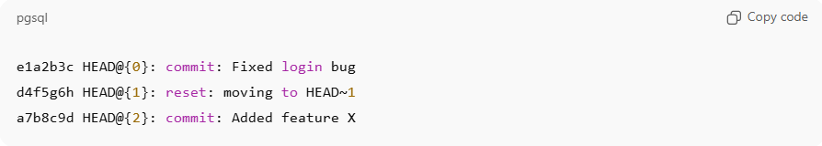
e1a2b3c HEAD@{0}: commit: Fixed login bug
d4f5g6h HEAD@{1}: reset: moving to HEAD~1
a7b8c9d HEAD@{2}: commit: Added feature X
- HEAD@{0} = current HEAD
- HEAD@{1} = previous state
- The hash shows the commit ID you can use to recover.

Common Uses
# Source: AI Source: Provided by: [Data Path: Persons Table -> ID Column: 1, Name_En Column: Motasem Essam] -> From: [ChatGPT] on [2/15/2026]
- Recover lost commits
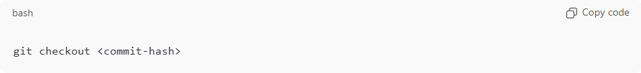
git checkout <commit-hash>
- Undo a destructive reset
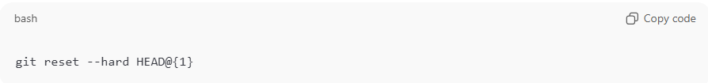
git reset --hard HEAD@{1}
- Find previous branch states after rebasing or merges.

Key Points
# Source: AI Source: Provided by: [Data Path: Persons Table -> ID Column: 1, Name_En Column: Motasem Essam] -> From: [ChatGPT] on [2/15/2026]
- Reflog is local: it only exists in your repository, not on remote.
- Entries expire after a default of 90 days, but can be configured.
- Extremely useful as a safety mechanism if you accidentally delete or rewrite history.

💡 Example scenario:
# Source: AI Source: Provided by: [Data Path: Persons Table -> ID Column: 1, Name_En Column: Motasem Essam] -> From: [ChatGPT] on [2/15/2026]
You did:
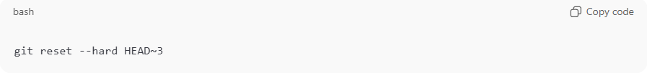
git reset --hard HEAD~3
and realized you lost your last three commits. With git reflog, you can find the commit hashes and restore them.

